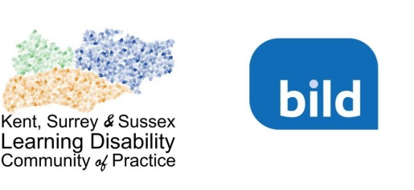

Sustaining Our Community
The Kent, Surrey & Sussex Learning Disability Community of Practice 2018 Conference
Thursday 21st June 9am to 5pm, The Charis Centre, Crawley, Surrey RH11 7EL

The Kent, Surrey & Sussex Learning Disability Community of Practice is pleased to announce the date of its 2018 conference. The theme for the day will be: Sustaining Our Community.

The intended outcomes of the conference are for participants to share and hear about good practice initiatives in the care and support for people with learning disabilities, to be consulted about how the Community of Practice might develop in the future and to network with other Community of Practice members.

The conference will include:

- keynote speakers
- workshops presented by Community of Practice members highlighting good practice initiatives
- consultation about the future sustainment of the Community of Practice and report of progress to date
- recruitment of ‘champions’
- market stalls
- posters produced by Community of Practice members highlighting good practice initiatives
- the production of a film of day

Call for Contributions
The Community of Practice is looking for local people from across Kent, Surrey and Sussex to present local good practice initiatives and to share their work at the Conference in a workshop or by producing a poster.

If you are interested in doing this either download the form below and return it to L.howells@bild.org.uk or click on the following link to submit you interest online [click to download submission form.]

The closing date for applications to run workshops or produce posters is 11t^{h} May 2017. Applications should focus on the three purposes of the Community of Practice which are to:

- Be person centred
- Provide the best quality care and support and
- Improve equality and access.
Criteria for selection
Conference organisers will decide which applications are successful based on the following criteria:
- The title is clear and describes the content
- The abstract is less than 300 words
- The workshop or poster focuses on the three purposes of the Community of Practice
- The content is relevant to the Community of Practice members
- The content of the workshop or poster is explicit
- Materials to be used are inclusive and easy to understand, to meet the needs of every member of the Community of Practice.

APPLICATION FORM

Submission for Workshops and Posters

Name
Role (if applicable):
Organisation (if applicable):
Email address:
Telephone number:
Address

What is the title of your workshop or poster?

Poster or presentation? Do you want to produce a poster or run a workshop?

Yes/No
- Poster
- Workshop

Workshop requirements: Does your workshop require any particular facilities?

Yes/No
- Audio visual equipment
- Anything else

Abstract: Please produce a brief summary of the work you would like to share in no more than 300 words.

