BW Story App
Picture stories to enrich the lives of the people you care about

The BW Story App is a fast and simple way to access pictures that will help enable the people you care about to explore and understand the world. It is a unique and easy to use mobile tool, which aids communication, decision making and self-exploration, to support people who find pictures easier to understand than words.

Unparalleled picture-based story app for people with learning disabilities and autism is a necessary tool for professionals, supporters and carers

For over 25 years Beyond Words have been creating books with and for people with learning disabilities, as well as young people and adults with autism and SEMH (social, emotion and mental health needs). With over 45 titles in print it was time to switch to the digital realm and offer additional platforms for people to share their stories. With the new BW Story App you can now access 1800+ pictures and over 400 scenarios (short stories) at your fingertips.

“An App that has Beyond Words materials will significantly enhance clinical care. It promotes shared decision making, thereby improving outcomes for people with learning disabilities and their families. The benefit of an App is its ease of use and access and means it is readily available wherever the clinician is. By using Beyond Words in an offline manner such as an App means it is instant, searchable and robust evidence based information which will ensure clinicians can aid their patients’ understanding as well as assess their level of understanding of what is going to happen and the patients’ views.” Jim Blair, Consultant Nurse, Intellectual (Learning) disabilities, Great Ormond Street Hospital, Associate Professor Intellectual Disabilities, Kingston and St George’s Universities

Books Beyond Words use pictures to tell stories that engage and empower people, on themes such as love and relationships, health, death and dying, and crime. They are also a tool for professionals to use with people in many different teaching and counselling situations. The BW Story App allows the user to access stories through nine carefully selected categories or through a keyword search.

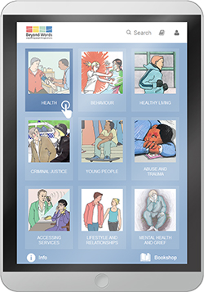
You can choose from nine categories:

- Health
- Behaviour
- Healthy Living
- Criminal Justice
- Young People
- Abuse and Trauma
- Accessing Services
- Lifestyle and Relationships
- Mental Health and Grief

Or use the ‘keyword search’ function

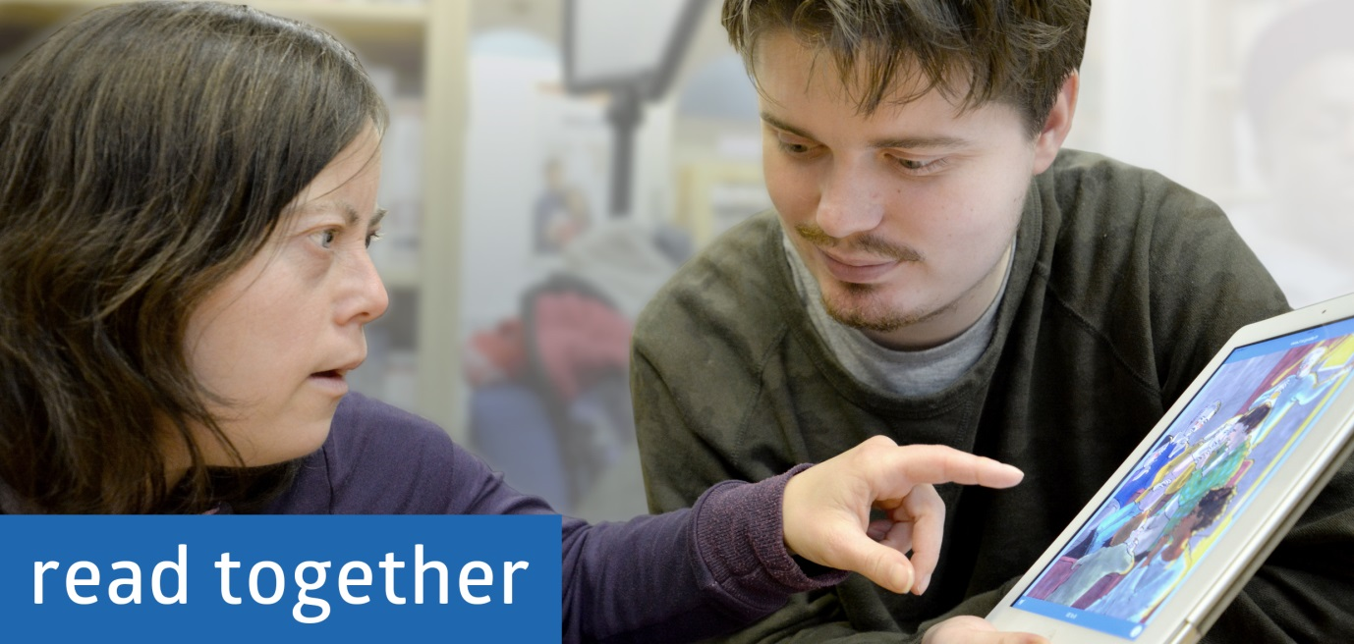

A tool for supporters
For a supporter, having the best tools on hand 24/7 to aid communication and comfort the person you are supporting is invaluable. Through the App, busy professionals can now access Beyond Words resources on the move and instantly. Accessing a story about somebody experiencing a blood test exemplifies the power and potential that lies within the App to support and empower people; ideal for LD nurses, GPs or family/carers. Rather than simply illustrating a needle and an arm, the pictures tell the story of Ann and her giving consent, taking you step-by-step through each stage of the interaction, acknowledging momentary feelings of pain or fear, looking at what happens to the blood after it’s taken and finally showing Ann happy after the procedure is over. This story will allow the supporter to discuss what’s going to happen in detail with the patient. The patient will look at the images and spend time thinking and discussing what is happening in each picture. Patients can identify, process and communicate their own feelings and concerns through the events and characters they see in the story.

'It is a client-centred resource of power and courage.' British Journal of Learning Disabilities
(in reference to the Beyond Words book, I Can Get Through It)

The BW Story App is enriched with 25+ years of meticulous trialling and design
Producing each Beyond Words book involves 18 months of trialling, drawing and development. Every image that makes up the books, and now the BW Story App, has been looked at in detail by up to 100 individuals including people with learning disabilities, professionals and supporters. Hundreds of people and thousands of hours have been spent creating Beyond Words’ vast catalogue of information and enriching narratives. As new books and materials are produced they will be systematically added to the App meaning that the App will continue to grow, year upon year.

'We need to create a bit of a revolution. I would like to see these books distributed widely.'
Dr Dominic Slowie, National Clinical Director for Learning Disability, NHS England

How to purchase
You can download your free version of the App via Google Play (Android) or iTunes (iOS). Simply search for ‘BW Story App’. The Full version, with access to over 400 stories, is available via in app purchase, on an annual subscription basis.
There is also the opportunity to subscribe to the full bookshelf, getting access to all the Beyond Word titles. www.booksbeyondwords.co.uk/story-app
This is available for individuals via our website, or to organisations upon enquiry.

“These books are there to help tell a story and put that story into pictures so that everybody can understand." The Rt Hon. Baroness Scotland of Asthal QC (EDV Global Foundation / co-author)

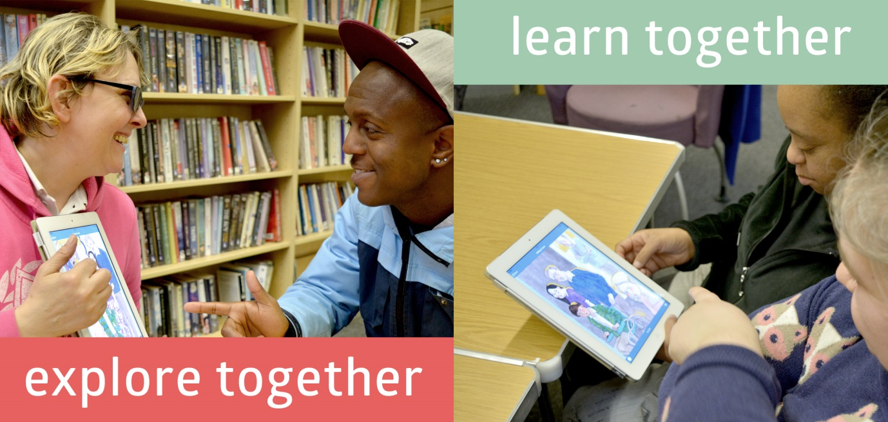

Conclusion
The BW Story App allows you to carry the stories from all 50 books in your pocket. It allows you to access stories via a user-friendly categorised interface or via a keyword search. If you are a professional, supporter or carer and need to react to the concern of young person or adult at short notice, you can simply pull the relevant images up on your phone or tablet. An LD nurse can carry all the resources around a busy ward, adapting to the specific needs of every patient. If you are a parent or carer working with a young person who you know prefers the iPad over a book you can share the stories together swiping the screen to turn the pages. The app offers portability, regularly updated material, links to physical products and as stated previously, a culmination of a quarter century’s research and production.

You can also discover more at www.booksbeyondwords.co.uk/story-app

